Cài mach3 share data với pokeys  
  
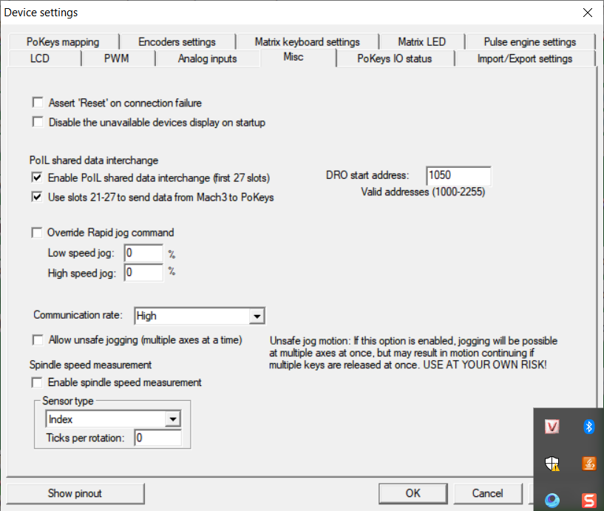  
  
Dùng machScreen để tạo button với VB script cho các nút set zero của encoder.  
ta dùng địa OEM 1075 để share data với pokeys

Các data được đặt là 150 cho zero x, 300 cho zero y, 450 cho zero z

Message( "Zero encoder X." )

SetOEMDRO(1072,0)

Sleep ( 100)

SetOEMDRO(1071,150)

Sleep ( 100)

SetOEMDRO(1071,0)

Message( "Zero encoder Y." )

SetOEMDRO(1072,0)

Sleep ( 100)

SetOEMDRO(1071,300)

Sleep ( 100)

SetOEMDRO(1071,0)

Message( "Zero encoder Z." )

SetOEMDRO(1072,0)

Sleep ( 100)

SetOEMDRO(1071,450)

Sleep ( 100)

SetOEMDRO(1071,0)

Encoder

Sub Main()

Begin Dialog GroupSample 31,32,120,96,"Axis Selection"

OKButton 38,75,40,14

GroupBox 12,8,96,62,"Pick Encoder Axis to Calibrate",.GroupBox1

OptionGroup .OptionGroup1

OptionButton 20,24,40,8,"X Axis",.OptionButton1

OptionButton 20,40,40,8,"Y Axis",.OptionButton2

OptionButton 20,56,40,8,"Z Axis",.OptionButton3

End Dialog

Dim Dlg1 As GroupSample

Button = Dialog (Dlg1)

If Button = 0 Then

Exit Sub

End If

AxisNum = Dlg1.OptionGroup1

Select Case AxisNum

Case 0 'HSS

Axis = "StepsPerAxisX"

DROAxis = 1073

DROEncodervalue = 1000

Axis_Letter = "X"

Case 1 'HSStin

Axis = "StepsPerAxisY"

DROAxis = 1074

DROEncodervalue = 1001

Axis_Letter =" Y"

Case 2 'Carbide

Axis = "StepsPerAxisZ"

DROEncodervalue = 1002

DROAxis = 1075

Axis_Letter = "Z"

End Select

Encoderbegin = GetUserDRO(DROEncodervalue)

Com_Move = Question ("How far would you like to Move the " & Axis_Letter & " Axis?")

If COM_Move = 0 Then

MsgBox "Can't have a Move of Zero, Axis Calc aborted."

Exit Sub

End If

Code "G0 G91 " & Axis_Letter & Com_Move

While Ismoving()

Wend

Code("G90")

Code "G4 P0.5"

Encoderend = GetUserDRO(DROEncodervalue)

Old_PPR = GetParam(Axis)

EncoderMove = Abs(Encoderend - Encoderbegin)

New_PPR = Abs(EncoderMove / Com_Move)

Response = MsgBox ( Axis_Letter & " Axis Will be Set to " & New_PPR & " Counts/rev. Would you like to Accept it??", 4 , "Set Counts/REV")

If Response = 6 Then ' User chose Yes.

SetUserDRO(DROAxis , New_PPR)

MsgBox ("Encoder " & Axis_Letter & " Axis Has Been Set")

Else ' User chose No.

MsgBox ("Encoder " &Axis_Letter & " Axis Has NOT Been Set")

End If

End Sub

Main